Activity Practice 1: UML Deployment Diagram
Goal: Model the physical allocation of software components (nodes) to execution environments (hardware/containers).
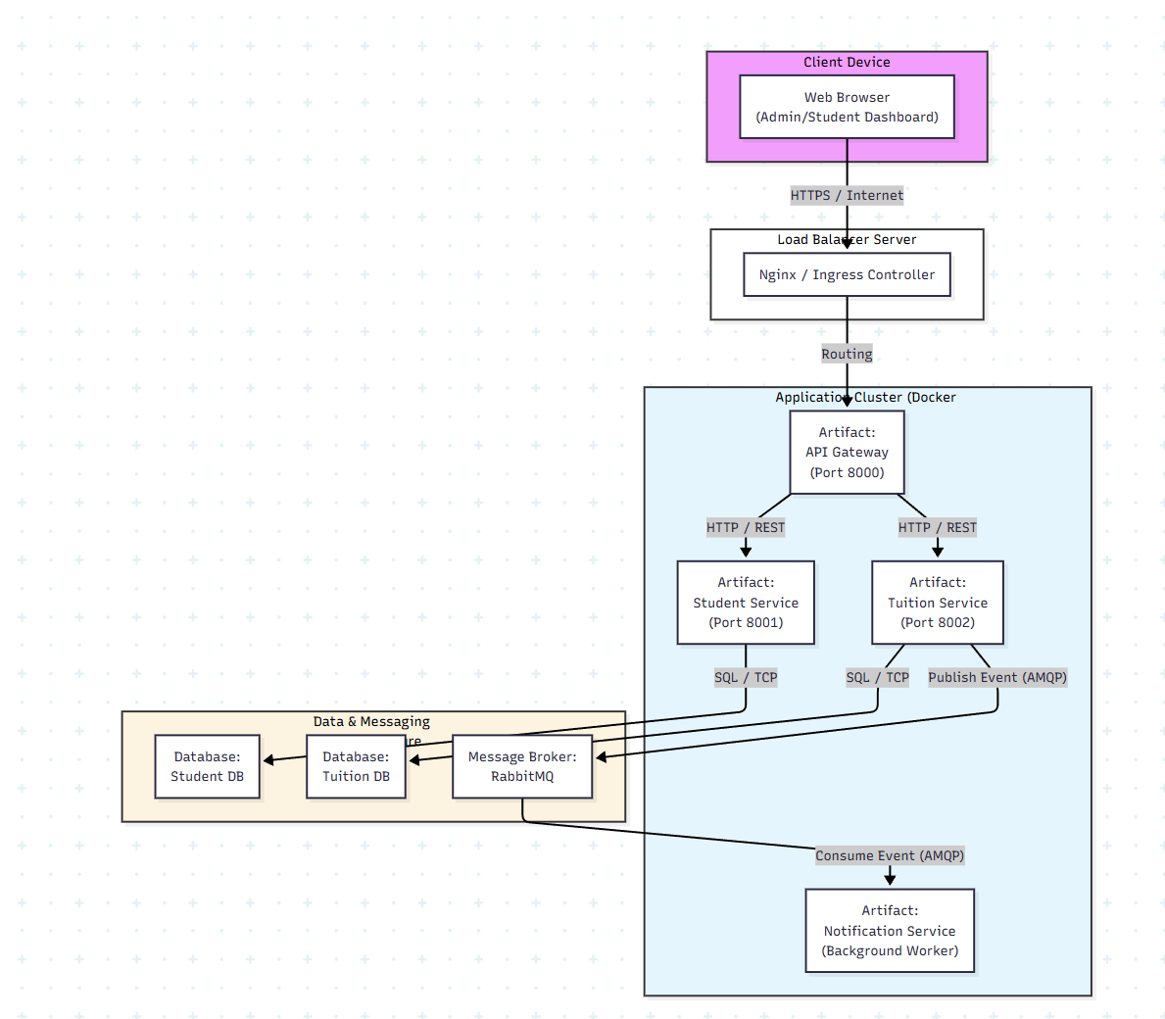
Activity Practice 2: Quality Attribute Analysis (ATAM)
Goal: Conduct a simplified Architecture Trade-off Analysis Method (ATAM) to compare your old Monolithic Architecture (Labs 1-3) vs. the new Microservices Architecture (Labs 4-7) regarding Scalability and Availability.

1. Define Scenarios
- Scalability Scenario (SS1): "During the course registration period, the system experiences a 20x spike in traffic specifically for Viewing Class Lists and Registering Courses (Student Service). The Tuition payment function is rarely used during this time."
- Availability Scenario (AS1): "The Notification Service (Email) crashes due to a bug or SMTP server failure while a student is trying to pay tuition."
2. ATAM Analysis Table
Quality Attribute | Scenario | Monolithic Approach (Layered) | Microservices Approach
Scalability | SS1: Traffic spike on Course Registration. | Response: Inefficient.  You must scale/replicate the entire application (including unused modules like Tuition, Lecturer Management). This wastes CPU/RAM resources. | Response: Highly Efficient.  You can scale only the Student Service containers (e.g., run 10 instances) while keeping Tuition and Notification services at 1 instance. Resources are optimized.
Availability | AS1: Notification Service fails during payment. | Response: High Risk.  If the email logic is tightly coupled (Synchronous) within the Payment Controller, the email failure might cause the entire transaction to rollback or the user's browser to hang/timeout. | Response: Excellent (Fault Isolation).  Due to the Event-Driven Architecture (Lab 7), the Tuition Service simply publishes a message to RabbitMQ and completes the request. The failure of the Notification Service has zero impact on the payment success. The message remains in the queue until the service is fixed.

Activity Practice 3: Trade-off Statement
Goal: Summarize the architectural trade-offs identified during the analysis.
Trade-off Conclusion:
Transitioning the Student Management System to a Microservices Architecture provides superior Scalability for handling high-load events (like Course Registration) and high Availability through Fault Isolation (e.g., email failures don't block payments).
However, this comes at the cost of significantly increased Complexity.
- Deployment: Instead of deploying a single codebase, we now manage multiple projects (Gateway, Student, Tuition, Notification). * Infrastructure: Requires maintaining complex components like RabbitMQ and Docker containers.
- Debugging: Tracing errors across multiple services is more difficult than in a Monolith.
Recommendation: This architecture is ideal for large universities with high concurrency needs. For smaller institutions with low traffic, the Monolithic approach remains more cost-effective and easier to maintain.

